Students pursuing a serious interest in writing may apply to write a creative project or thesis in the senior year. Proposals for creative projects are submitted prior to fall registration. Applicants should have taken at least one creative writing course in the department, although this requirement may be waived. Space in the course is limited; enrollment is competitive.

Students in this seminar must be:
1) self-motivated writers, faithful to their writing schedule;
2) consistent readers of each others' work;
3) active participants in the workshop.

He is by far my favorite of the Contemporary Etiquette group. He wrote all those books, just on the meanings of the sniff. I always thought a sniff was just a sniff.

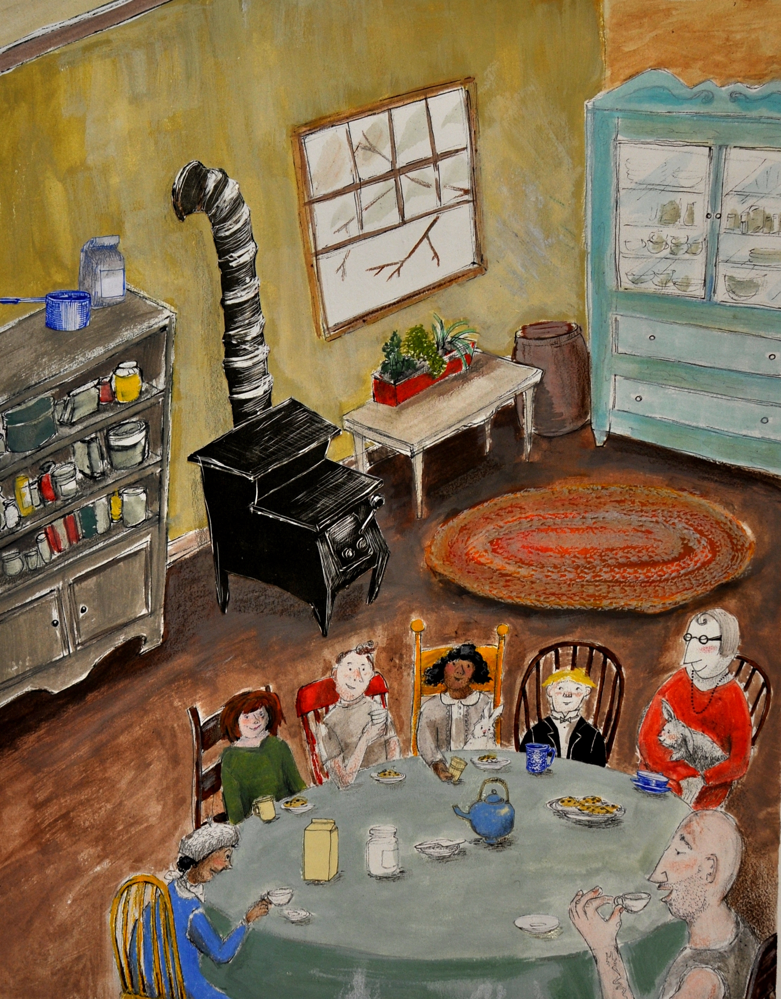

senior creative writers
spring 2012

Jen Christianson
My intention with this project was to write a series of memoir essays on last year, which I spent studying abroad in Oxford. I've ended up with a collection that hits all ends of the spectrum, from descriptions of London to full-blown stories about some of the most important relationships I built over in England. All, I hope, get at the joys and challenges of building a new little community far from home.

Allison Lynch
My collection of memoir stories focuses on relationships I’ve experienced with other people, including family, friends, men, or mere acquaintances who made a significant impression on my life. Within the framework or relationships, I convey the sense of brokenness, disillusionment, and sadness that came from growing up in a sheltered Christian home, which turned into a place of resentment and rebellion. The stories are raw and exposed, ranging everywhere from my encounters with homosexuality, drugs, rehab, sex, depression, and eating disorders, but with the underlying consistency of faith and God, no matter how distant and careless God may be depicted.

Erica Street
My project is a novel set in the future sometime after the scientific phenomenon known as the Singularity. I chose this setting because I am specifically interested in creating a story that delves into one of the major questions of the current age: technological advancement as a threat to humanity. My vision for the project was to create a realistic portrayal of life that attempts to get at the heart of what it means to be human in this age. Each of my characters struggle to deal with this question in their own way, only to find that all they can know for sure is that they have entered into a dark and chaotic world where the very nature and core of what it means to be human is challenged.

Brenna Case
My project for this semester was a set of short stories, all centered around an extended family living in a Midwestern university town. I wanted to explore the concept of place, especially, and how different characters identify and internalize it in different ways.

This is an excerpt from "The Shrimp Farm Baptism," which has nine-year-old Lydia getting baptized. Her grandfather, her parents, and her older sister Phoebe have all given her conflicting accounts of what baptism means and why it happens, and so she's dreading her own.

Chelsea Lecander
My thesis is a series of non-fiction vignettes about the experience of faith through surrounding (senses, nature, circumstance, being) and the ways faith is strengthened, brought into question, and solidified by what we experience in the world. Each individual glimpse is personal and self-contained in nature, but is ultimately meant to interwoven— to tease out nuance in the others with which it sits in conjunction. They are stories of nature and humanity: inklings, wanderings and wonderings about grace & God’s character.

Jessica Kane
I wanted to imagine and enter in to the stories I didn't get to hear during my time in Europe. I lived alongside thousands of other people who I never met, and I wanted to begin to meet who they might be through these works.

Mary Cote
This semester I've been exploring time, connectedness and place through a poetical lens. I've spent time with Mary Oliver and Billy Collins--who have shaped my understanding of poetry as a craft as well as the style of my poems. I hope my poems convey a sense of exploration into the ties that connect us to each other and the simultaneous freedom and constraint inherent in time. I appreciate any feedback you have on my work.

Katie Weber
My project focused on retelling the narratives of Greek and Roman myths and epics. Through series of flash fiction in which every piece expressed the perspective of a different character, I explored both sides of the Trojan War, the psyche underlying Orpheus’ pursuit of Eurydice into the underworld, and Iphigenia’s death at Aulis, among other stories. The goal of the project was to make the myths and epics more accessible to the reader by putting a human face on the untouchable heroes of classical literature.

Alyssa Bailey
I chose to write travel memoirs about my experience in Sydney, Australia last semester. Everything was different: psychologies, public transport, kangaroo pizza—you name it. In that upside down country, I learned not to take myself so seriously. Over the course of this term, I read excerpts from Bill Bryson's In a Sunburned Country, along with other satire infused works of Kurt Vonnegut and David Sedaris. I chose these authors simply because they capture trifling and dramatic differences seen in everyday ironies, exaggerating their idiosyncrasies, penning with a delicate balance of hilarity and grace. I have attempted to model my pieces after this satirical and reflective nature, writing freely about the things I found in Oz.

Elliot Jones
“Did King Arthur ever really exist? The only honest answer is, ‘We do not know, but he may well have existed.’ The nature of the evidence is such that proof is impossible. There is a certain amount of early material dealing with him, but the difficulty lies in distinguishing what is, if anything, history from what is legend.”
-Kenneth Hurlstone Jackson.

My piece tries to reconcile the King Arthur of legend with the King Arthur of reality by merging the two in a fantasy story that explains reality through mysticism and magic. I have written a 100+ novel (still in the works) that has created a brand new world using elements from folklore, legend, and myth that attempts to fill in the gaps of the historicity of Arthur while at the same time providing a meaty story. The excerpt deals with two characters I made up, who find themselves wading in the waters of a dangerous world wrought by King Arthur himself.

Sarah Bradley
Inspired by a creation of my sister’s and my childhood comes the adventure of a displaced 11 year-old whose parents leave her to studying lizards in Paraguay. She goes to live with her aunt who, in turn—though with good intention—drops her off at a newly opened “Manner School” on the edge of town. There, she begins a desperate quest to save a curious group of rabbits. When things don’t turn out as she anticipates, Midge, with the help of friends both expected and unexpected, must deal with the consequences of her mistake and with new understanding and a fresh approach save the rabbits again from the real villain.

