senior creative writers

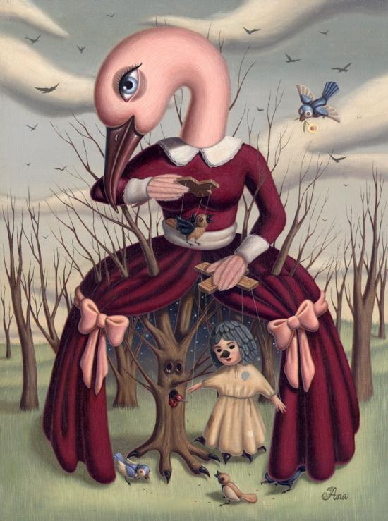

spring 2014 manuscripts

Students pursuing a serious interest in writing may apply to write a creative project or thesis in the senior year. Proposals for creative projects are submitted during fall registration. Applicants should have taken at least one creative writing course in the department, although this requirement may be waived. Space in the course is limited; enrollment is competitive.

senior creative writers

spring 2014 manuscripts

Students pursuing a serious interest in writing may apply to write a creative project or thesis in the senior year. Proposals for creative projects are submitted during fall registration. Applicants should have taken at least one creative writing course in the department, although this requirement may be waived. Space in the course is limited; enrollment is competitive.

Project Descriptions

Bri Young
This novel follows the lives of two children, Liv and Gavyn, and the old widower, Ezra, who adopts them. Liv washes up on the shores of Lesley (fictional village inspired by Irish/Celtic culture) as a seven year old and is found by an eleven-year old boy, Gavyn. This novel focuses on the harm of superstition, the reality of fear and the strange intricacies of faith.

Emily Macadam
Based on the novels Belong to Me and Falling Together by Marisa de los Santos, my 5-part piece explores the dynamics of ordinary friendships through loss. The story follows the daily lives of five friends and observes how the disappearance of one impacts the others over time. It also treats themes like regret and disappointment as the characters work to make sense of the unexpected, each in their own way.

Paul Fey
This semester, I worked on a novel based off psychology and philosophy classes, readings, research, and my own personal identity crisis, of sorts. I wanted to put contemporary research on memory and the narratives they provide to inform our ‘selves,’ in conversation with philosophical thought regarding phenomenology, dualism, physicalism and post-physicalism. Avoiding self important and stuffy writing, I tried to create an entertaining presentation, featuring an underground community of illegally prone psychologists, mad scientists, theologizing drug dealers and drug users, coma patients in a wild halfway house, and philosophy oriented meditators and moguls.

Ari Denardo
I have written a collection of poetry this semester, studying and attempting to mimic the techniques and topics in the work of such poets as Sylvia Plath, Wisława Szymborska, Adrienne Rich, and Ruth Stone. The poems that emerged from this process often explore postmodern religiosity, gender identity, and the terrain where sacred and profane meet.

Nicky Lee
I am documenting my life story thus far starting from the unfortunate death of my mother and the impact it has had on me throughout my life. My hope is that the story of my struggles and redemption will give readers hope amidst their struggles in life and find comfort that they are not alone in their suffering.

Liz Maurer
Five years after her brother's death, Kai Brennan is still struggling with her grief. When she receives a phone call from her parents, she learns that as they began to clean out Dylan's bedroom, they found a list he had created of "Things to Conquer". In an attempt to find some sort of closure, Kai decides to go through the list-- to conquer what Dylan had been unable to in his short life.

Steven Kennedy
My stories are set in a town called Nampa, Idaho. It is a place where people live--not successfully, but not terribly--and small things happen to them.

Mallory Moench
In today's globalizing world of migration and multiculturalism, what makes us who we are? How do we define who "we" are - who we belong with - and who the "other" is - who we conflict with? My collection of four short stories explores these questions of identity creation and destruction in light of gender, culture, race, and religion, seeking to give voice the diversity and complexity of identity around the globe. ​

Jon Lewis
Three young children go missing from the small Pennsylvanian town of Selleck Weed, causing widespread panic. While the town's adults look for the kidnapper, young, socially-awkward Elise discovers the truth within her closet; a secret committee of monsters hunting down the renegade deamon consuming the children. With just a few friends, and a conspicuous monster named Mr. Sunday, Elise goes into the forest to find and bring home the lost children.

Project Descriptions

Bri Young
This novel follows the lives of two children, Liv and Gavyn, and the old widower, Ezra, who adopts them. Liv washes up on the shores of Lesley (fictional village inspired by Irish/Celtic culture) as a seven year old and is found by an eleven-year old boy, Gavyn. This novel focuses on the harm of superstition, the reality of fear and the strange intricacies of faith.

Emily Macadam
Based on the novels Belong to Me and Falling Together by Marisa de los Santos, my 5-part piece explores the dynamics of ordinary friendships through loss. The story follows the daily lives of five friends and observes how the disappearance of one impacts the others over time. It also treats themes like regret and disappointment as the characters work to make sense of the unexpected, each in their own way.

Paul Fey
This semester, I worked on a novel based off psychology and philosophy classes, readings, research, and my own personal identity crisis, of sorts. I wanted to put contemporary research on memory and the narratives they provide to inform our ‘selves,’ in conversation with philosophical thought regarding phenomenology, dualism, physicalism and post-physicalism. Avoiding self important and stuffy writing, I tried to create an entertaining presentation, featuring an underground community of illegally prone psychologists, mad scientists, theologizing drug dealers and drug users, coma patients in a wild halfway house, and philosophy oriented meditators and moguls.

Ari Denardo
I have written a collection of poetry this semester, studying and attempting to mimic the techniques and topics in the work of such poets as Sylvia Plath, Wisława Szymborska, Adrienne Rich, and Ruth Stone. The poems that emerged from this process often explore postmodern religiosity, gender identity, and the terrain where sacred and profane meet.

Nicky Lee
I am documenting my life story thus far starting from the unfortunate death of my mother and the impact it has had on me throughout my life. My hope is that the story of my struggles and redemption will give readers hope amidst their struggles in life and find comfort that they are not alone in their suffering.

Liz Maurer
Five years after her brother's death, Kai Brennan is still struggling with her grief. When she receives a phone call from her parents, she learns that as they began to clean out Dylan's bedroom, they found a list he had created of "Things to Conquer". In an attempt to find some sort of closure, Kai decides to go through the list-- to conquer what Dylan had been unable to in his short life.

Steven Kennedy
My stories are set in a town called Nampa, Idaho. It is a place where people live--not successfully, but not terribly--and small things happen to them.

Mallory Moench
In today's globalizing world of migration and multiculturalism, what makes us who we are? How do we define who "we" are - who we belong with - and who the "other" is - who we conflict with? My collection of four short stories explores these questions of identity creation and destruction in light of gender, culture, race, and religion, seeking to give voice the diversity and complexity of identity around the globe. ​

Jon Lewis
Three young children go missing from the small Pennsylvanian town of Selleck Weed, causing widespread panic. While the town's adults look for the kidnapper, young, socially-awkward Elise discovers the truth within her closet; a secret committee of monsters hunting down the renegade deamon consuming the children. With just a few friends, and a conspicuous monster named Mr. Sunday, Elise goes into the forest to find and bring home the lost children.

